**ECEN 4610 – Capstone Laboratory**

**Electrical Impedance Tomography Machine Design:**   
**An Open-Source Approach**

**Diego Sena, Jonathan Kleppinger, Keegan Erickson**

***Department of ECE, University of Colorado, Boulder***  
 ***Grand Junction, CO, USA, October 27, 2023***

1. Executive Summary 2

2. Problem Definition 3

2.1 PROBLEM SCOPE 3

2.2 TECHNICAL REVIEW 3

2.2.1 INDUSTRY BACKGROUND 3

2.2.2 CLIENT BACKGROUND 6

2.2.3 CURRENT PROCESS 6

2.2.4 EXISTING SOLUTIONS 6

2.3 DESIGN REQUIREMENTS/CRITERIA and Engineering Standards 7

3. Design Description 9

3.1 OVERVIEW 9

3.2 DETAILED DESCRIPTION 10

3.2.1 SYSTEM/COMPONENT 1 - Control 10

3.2.2 SYSTEM/COMPONENT 2 – Current Injection 10

3.2.3 SYSTEM/COMPONENT 3 - Measurement 11

3.2.4 SYSTEM/COMPONENT 4 – Power Supply 11

3.3 USE 11

4. Evaluation 12

4.1 OVERVIEW 12

4.2 Evaluation of Howland Current Source Circuit and Signal Generation 13

4.2.1 Purpose of Evaluation 13

4.2.2 Test Methods (include discussion of prototyping if applicable) 13

4.2.3 Results and Discussion 13

4.3 EVALUATION OF QUADRATURE DEMODULATION 14

4.3.1 Purpose of Evaluation 14

4.3.2 Test Methods (include discussion of prototyping if applicable) 14

4.3.3 Results and Discussion 14

4.4 Evaluation of Control System 16

4.5 Evaluation of Data Processing 17

4.6 Evaluation of CNC Milled PCB Process 18

4.7 Conclusion and Next Steps 18

5. Impact of Engineering Solutions 18

5.1 GLOBAL IMPACTS 18

5.2 ECONOMIC IMPACTS 19

5.3 ENVIRONMENTAL IMPACTS 20

5.4 SOCIETAL IMPACTS 21

5. References 23

6. Appendices 23

# Executive Summary

Electrical Impedance Tomography (EIT) is a non-intrusive medical imaging technique for viewing a cross section of an area [1]. Common imaging applications include the viewing of the heart and lungs, brain, and breast tissue. Two currents 180 degrees out of phase into a plane of the human body. Electrodes surrounding the cross-sectional area of the body are used to measure varying voltages to create an image showing the varying impedance, conductivity, and permittivity throughout the tissue plane. This document outlines the design of an EIT machine using programs and hardware aimed at creating cheaper and more open-source methods of manufacturing, that are accessible to the general public and university students. 

# Problem Definition

## PROBLEM SCOPE

This paper documents the design and construction of an EIT machine using methods and hardware that are accessible to the general public and university students. The project sponsor for whom the development of the EIT machine is being done is Dr. Talles Santos, a professor of electrical engineering who is working for the University of Colorado, Boulder.

The project sponsor has extensive experience in high quality EIT machine development and research. Motivated by a desire to continue the research in EIT and make the technology more accessible, the project sponsor would like to use continued development of EIT to educate students in the application of the technology. The project sponsor has experience working with other grad students and professors on the development and construction of EIT machines and would like to expand its development to include the work of under grad students. Currently there is no EIT machine at the location of Colorado Mesa University (CMU), where the project sponsor is physically located and works. This project will be the beginning of a goal to make CMU a new center for the development of the technology.

The project sponsor has tasked the 2022-20123 senior design team with starting a path to creating a fully open-source model for the construction of an EIT machine. Using components available and relatively inexpensive integrated circuit (IC) components, a fully functional EIT machine with real-time imaging is to be constructed. The construction of the EIT machine was to maintain a cost below $3,000.00 of the total budget.

## 2.2 TECHNICAL REVIEW

### 2.2.1 INDUSTRY BACKGROUND

Electrical Impedance Tomography (EIT) is a noninvasive medical imaging technique. The imaging technique uses alternating current (AC) that is injected into the human body to create a tomographic image of a cross sectional area. Voltages are read through electrodes placed on the surface of the skin surrounding the area to be imaged. The voltage readings are then used along with the injection current to calculate variations in impedance, conductivity, and permittivity through the biological tissue to create the tomographic image of the cross-sectional area.

Direct Current (DC) and low frequency electricity does not pass easily through biological tissue. Which is the reason why higher frequency AC electricity is needed. There is significant variation in impedance, conductivity, and permittivity between different types of biological tissue. This variation in impedance is what allows for the production of tomographic images of the body. Variation in impedance is due to the free ion content of tissue. Electrical impedance is shown by the expression in Equation (1) [2].

 (1)

Where Z, the electrical impedance, is equivalent to R, the resistance, and X the reactance. Conductivity and permittivity are typically what is used in the actual imaging of tissue. Conductivity is the reciprocal of impedance and is expressed in Siemens per meter (S/m). Typically, the more fluid filled tissue is, the more conductive it is. Typical values for conductivity are shown below in Table 1. A specific organ of note, the lungs, has much higher impedances than other organs. This is because air has a very high impedance.

Table 1: Shows the difference in conductivity between different tissue types [1]

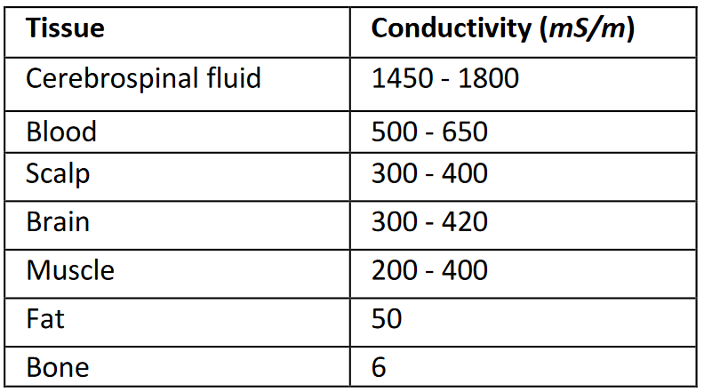

The differences in conductivity are mapped out using electrical excitation caused by two injection current sources. These two injection currents have the same frequency and amplitude but are 180° out of phase from each other. While one injection current is positively charged, the other will be negatively charged. In conventional current terms, current will flow from positive charge to negative charge. Electrodes surrounding the tissue are used during the current injection process to take voltage readings. Current injection sites are at the same locations as the electrodes, but only 2 at a time are activated at once. The turned-on current injectors rotate to the next injectors after a period of time that is optimal for the measurement process. The current injectors that are turned on depend on the process chosen. Figure (2) shows a visualization of the injected currents streamlines traveling between the two current injection sources.

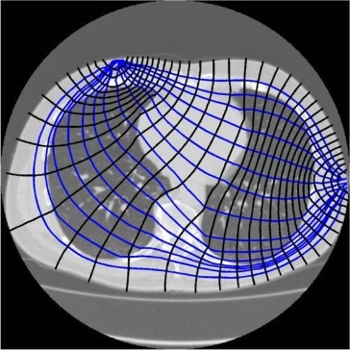

Figure 1: Shows a visualization of current streamlines traveling between two current injection sources [1]

### 2.2.2 CLIENT BACKGROUND

Dr. Talles Santos received his Bachelor of Science degree in electrical engineering from the federal University of Minas Gerais, Belo Horizonte, Brazil, in 2012, Earned a master's degree in 2015 and his PhD in 2019, both in control engineering and mechanical automation from the Polytechnic School at the University of São Paulo, Brazil.

Dr. Santos has more than 10 years of experience in the EIT field. He worked part time at Timpel Medical, São Paulo, Brazil, working on EIT development [3]. Also, he has worked with several other groups developing EIT for medical applications. Currently he is a professor of electrical engineering who is working for the University of Colorado, Boulder. He now wants to start further development of EIT technology at CMU, while using the opportunity to educate students in the principles of how EIT works and how to construct a machine. Dr. Santos wants to make the technology cheaper and more accessible to medical professionals and individuals who want to study and help further develop the technology [3]. EIT machines require the coordination of high frequency current injection, sampling processes, and control circuitry at high speeds in order to achieve real time imaging with a resolution that is usable for a medical professional. The construction of such a machine is a lot of work for one individual to undergo. The sponsor requires the assistance of other individuals well versed in electrical and computer engineering, which is the reason why the 2022-2023 capstone team has been tasked with assisting the sponsor in the construction of an EIT machine.

### 2.2.3 CURRENT PROCESS

Currently there is no EIT machine working or in development at CMU. This project will be the beginning of its development at CMU.

### 2.2.4 EXISTING SOLUTIONS

The existing solutions for this project are made by companies with closed solutions. Some of the existing manufacturers are Timpel (Dr Santos' former employer) [3], Sentec [4], Drager [5], and Sciospec[6]. Sciospec replied to the team with a quote for a medical grade 64 channel EIT machine the price is about $60k. This is outside the budget of the sponsor, and it severely limits the modifications that can be made to the device. In addition, the sponsor wants the project to be more open source and to not use proprietary or expensive commercial hardware.

This means that this project will be building each component from the ground up. The project sponsor has many years of experience in EIT application and research. There are three major components to design. First is a current injection system, second is the measurement system, third is the control system.

First, the current injection system, which injects current into the patient to be measured by the measurement system. There are specific methods of current injection patterns, creating a stable current injection source, and signal extraction that were recommended. For current injection, the skip four method was recommended by our sponsor. The skip four method is when the bipolar current injection is done between two electrodes spaced 4 electrodes apart, at all times. There are no current sources that would match our requirements and that would be within our price range.

Second, the measurement system has three main requirements. First is the precision of the system, second is the sampling frequency, and third is synchronization of the measurements. The sponsor provided two National Instruments PCI-6259 DAQ boards (NI boards for short) for the project. These boards are 125 kS/s when using 32 channels that will have 1mV precision with the ability to synchronize all the channels together.

Third, the control system, which oversees the current and measurement systems so they can work together. This system needs to have the processing power to run faster than the current and measurement systems to be able to coordinate the systems together. There are many existing solutions for the control system. Diego has proved an old desktop to use. The desktop has the ability to connect the two measurement boards to the motherboard and use the software to collect data and process it into an image.

## 2.3 DESIGN REQUIREMENTS/CRITERIA and Engineering Standards

The project deliverable is a functioning EIT machine capable of:

* Three-Frequency Signal Generation
  + Ideally consisting of 80, 100, and 120 kHz frequencies
  + 10mA RMS current injection
    - Accurate within 0.1mA
* 32 Channels of voltage readings
  + Sample size (500 - 1024)
  + Use the two provided NI PCI-6259 DAQ boards (NI boards)
    - Highest sampling rate possible with NI board
    - Maximum rate of 1 MS/s single channel possible
* Real-Time imaging
  + Ideally 32x32 bits
* Buffer between measurement and electrodes
* Control system to map the current delivery to desired electrodes
  + Synchronizes with measurement process
  + Implements the "skip 4 method"
* Safely limit current
  + To ensure test subjects are not shocked
  + To provide redundancy in power supply current protection
* Implement central control through the use of a desktop computer
  + Use the computer monitor to display the real time imaging
* Develop a working process to rapidly prototype PCB boards
* Use MATLAB to display imaging and process data

Three frequency current injection into the test subject is necessary for various reasons due to the impedance characteristics of biological tissue as described in section 4.2.1. Three frequency current injection is favored as an optimal way that the sponsor has found to get a more precise image. The 10 mA rms current amplitude is considered by the sponsor to be sufficient to provide voltage readings that will be above noise levels at a level that makes taking the voltage readings possible, without injecting too much current that it becomes unsafe for a patient. The skip four method of current injection has been shown through the sponsor's research to be the most effective way to inject current for good imaging. The skip four method is when the two current injection sources are spaced 4 electrodes away from each other, and this pattern alternates in a clockwise pattern.

Thirty-two channels of voltage readings from the electrodes are necessary to construct an image of the quality the sponsor is hoping to achieve. Too low of a resolution on the image will leave the image obtained from the device too difficult to be useful for medical purposes. These 32 voltage readings are necessary to achieve a 32x32 bit image. A minimum of 500 samples should be acquired in a buffer during the sampling measurement process, with an ideal target 1024 samples.

Use of the NI boards provided is desired by the sponsor because it has already existing toolboxes and has drivers available for simple integration with MATLAB, which the sponsor desires for data processing and imaging.

The desktop will be used for controlling the devices and for allowing modular design as swapping in and out parts will be easier. The desktop will be able to control the current injection source and the measurement system at the same time to produce synchronized data. Then the desktop will have the power to process the data into an image as the measurement system takes another set of data to be processed. Implementing a computer for central control in this way will simplify operation of the EIT machine for the sponsor.

Published by the International Electrotechnical Commission (IEC), IEC 6061 is a list of technical standards for the safety and performance of medical electrical equipment [7]. These standards are considered as necessary in many countries by law and is widely accepted as a necessary list of requirements for product development for many companies and corporations. Another set of standards provided by the American National Standard Institute is the ANSI/AAMI ES60601-1:2005, which also includes standards on electrical equipment [8]. Standards that may apply to the development of the EIT machine include calibration of the ADC and electrical safety standards.

# 3. Design Description

## 3.1 OVERVIEW

A computer with adequate clock speeds is critical to control multiple running processes at the necessary speeds. A central computer will be necessary to control and coordinate all the machine's components and processes. From this central control desktop computer, two NI boards generate and read analog voltage signals and digital signals. The generated analog voltage signals are used to control a current source for injection into the test subject. The electrodes receive the injection current directed by the control circuit, controlled by the NI boards' digital output pins. While the current injection is constantly occurring, the NI board reads all 16 electrodes placed around the test subject. These analog signals read from the electrodes are then collected by a program and used to generate a real-time image.

Coordinated by the control desktop using the NI Boards, a small multifrequency signal is sent through a voltage controlled current source. The signal is restricted to a consistent output despite the body's various impedances. Then the signal is directed to the body's active electrodes using the digital logic from the desktop to the multiplexers. Using the same active electrodes, the signal is both sent and read. The signal data is sent to the MATLAB (software) script where the signal is properly extracted and reconstructed into the image.

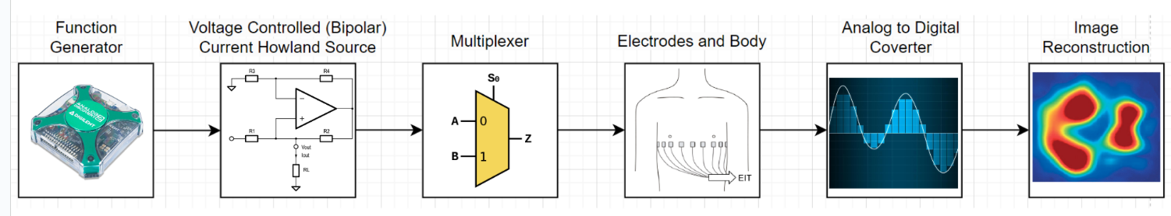

Figure 2: Block diagram of the independent stages within the EIT machine.

## 3.2 DETAILED DESCRIPTION

### 3.2.1 SYSTEM/COMPONENT 1 - Control

The control system circuit consists of two 16:1 multiplexor (MUX) ICs. The specific component used in the design was the ADG406BNZ, from Analog Devices Inc. These MUXs are designed to direct 16 different signals to or from one destination or source. The MUXs are being used to direct a current from a respective Howland current source to one of 16 electrodes. The 16 MUX outputs connect the 16 electrodes with the NI Boards read channels and are directed by 4 digital control signals. Connecting each output of the MUXs will halve the amount of wire needed and will not be an issue because the MUXs will not have the same channels, permitting current flow at the same time. A single 12 V supply will power the MUXs. A simple diagram of the control circuit is shown in Figure 3.

Figure 3: Block diagram of the MUX control circuit

### 3.2.2 SYSTEM/COMPONENT 2 – Current Injection

The current injection system consists of a multifrequency bipolar signal. The signal contains a 10k, 25k, and 50k Hz signal with a peak current of 10mA. The signals will be generated using the NI boards 180 degrees out of phase. The signal will then be sent through the Howland current source where the current is restricted. The body has a varying impedance as the patient breathes and the Howland current source keeps a constant current output while impedance varies. Figure 4 below shows both sides of a completed current source circuit.

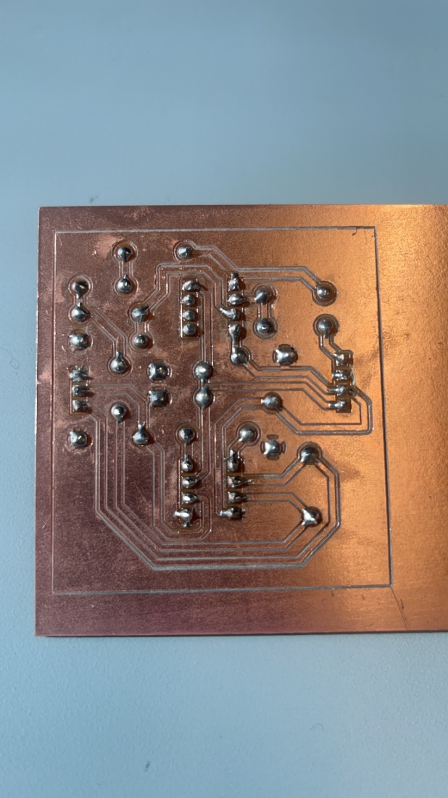

Figure 4: PCB of Howland current source milled from CNC mill.

### 3.2.3 SYSTEM/COMPONENT 3 - Measurement

The measurement system consists of 16 electrodes and two NI boards. The NI boards read analog voltage signals from electrodes, which pick up voltages created by the current injection system. The electrodes have buffers that isolate the patient from the NI board and the current directed by the MUX control circuit. The voltages read by the NI board are then processed by a program written in MATLAB to create with code supplied by Dr. Santos to create a real-time image. Figure 5 below shows a simple layout of the active electrode circuit. A white triangle on a black background

Figure 5: Active electrode circuit

### 3.2.4 SYSTEM/COMPONENT 4 – Power Supply

The power supply system provides power to all the IC components; each requiring a different voltage. The first component running from a 60Hz, 120 V, standard AC wall outlet is a 120 V AC to 24 V DC converter. Following this converter is multiple DC to DC converters. A 24 V DC to plus and minus 15 V DC converter is used to provide power to the two MUXs of the control circuit and provide power for the current source circuit.

## 3.3 USE

To be completed Later

# 4. Evaluation

## 4.1 Overview

The test plan for the EIT machine requires testing on many components. To be confirmed was that two three-frequency voltage signals, consisting of 10, 30, and 50 kHz, 180 degrees out of phase, were produced by the NI board that was to be then converted into a current signal that was not to exceed 10 mA, with a 1% margin of error for accuracy. This current signal delivery system was tested for accuracy and consistency with voltage measurements by taking voltage measurements with an oscilloscope over a resister.

A control system was also tested to ensure that timing and current direction would be delivered to the appropriate electrodes at the appropriate time. Testing of the control system was done by measuring voltage signals at the electrodes while stepping through the control system slowly while ensuring that the proper electrode was receiving the signal. The control system was also to implement the skip-four pattern of current injection.

The voltages produced on the electrodes were then to be read back in by the ADC of the NI boards to processed by a MATLAB script. Ideally this was to be done over 32 electrodes, at a sample rate of 1 Ms/s, verified by settings designated by the created MATLAB script. At each each phase of measurement, a single state of electrode current injection was to provide a sample size between 500 to 1024 samples, which was simply verified by viewing variables in MATLAB. MATLAB was also to be used to provide real-time imaging, which would be verified by viewing a real-time image of an object easily confirmed by placing objects in a saltwater tank. A signal extraction technique was used to extract only the desired input frequencies called Quadrature Demodulation and was tested greatly to ensure its accuracy.

Current into the system used to power all circuitry needed to be current limited as well to ensure safety. This was done by simply using adjustable DC voltage sources using a single Gw Instek GPP-3323 DC power supply. All circuits were to be done on CNC milled PCBs, was shown to be completed with physically created PCBs that were implemented into use on the EIT machine.

Table 4.1.1. Contains base requirements for EIT system.

* + 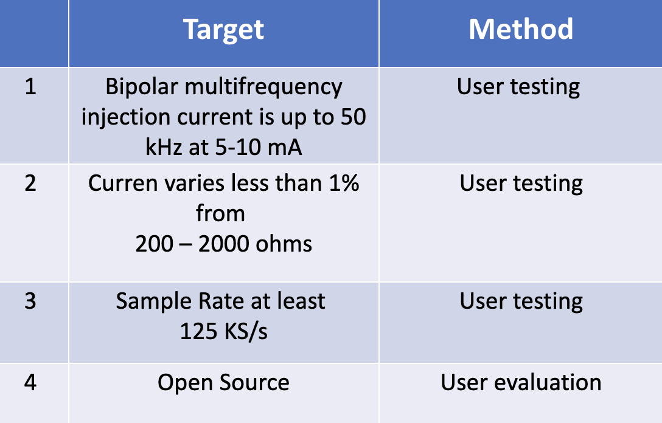

## 4.2 Evaluation of Howland Current Source Circuit and Signal Generation

### **Purpose of Evaluation**

The signal sent to the patient must maintain a stable current across the load resistance ranging from 500 to 2000 ohms. This requirement arises from the fluctuating resistance within the patient's body, particularly during breathing cycles and lung inflation. It is crucial to limit the deviation in current across these impedance ranges to within 1% to accurately capture the patient's impedance data, preventing distortion caused by signal artifacts. The Howland current source employs DC-blocking capacitors at the signal output to guarantee patient safety by preventing electric shocks.

### **4.2.2 Test Methods**

A single Howland circuit was tested with a variation of loads with an input signal at the maximum frequency of 50kHz and a 6Vpp signal. This expected approximately 7.75 mA output at 50kHz. This test allows the current to be as high as possible without beginning to saturate.

### **4.2.3 Results and Discussion**

When the current surpasses 8mA at 1500 ohms, the output signal begins to saturate due to the operational constraints of the Howlands AD8066 IC, which is powered by +/- 12 volts and cannot exceed this output value. To accommodate a resistance load of up to 2000 ohms, the design is limited to utilizing up to 6 mA. Considering the system will be tested on a tank with a resistance load of no more than 1500 Ohms, a current of 7.75 mA is applied to optimize performance while avoiding saturation, as indicated in Table 2. The table also displays an injection current error within 6.4%. Despite this proximity to the expected accuracy, it falls short of the desired 1% threshold set by our sponsor. Consequently, the generated images may exhibit minor distortion if impedance fluctuates between the minimum and maximum values.

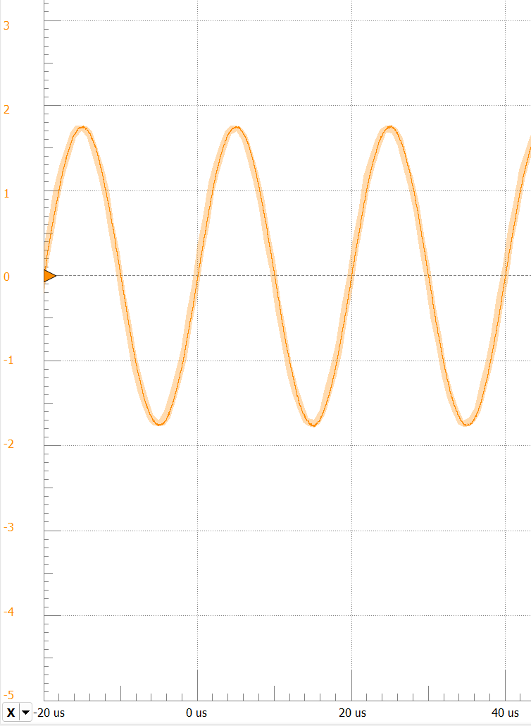

Figure 6: Voltage drop at 50kHz over the 468 ohm load.

|  |  |  |  |  |
| --- | --- | --- | --- | --- |
| Voltage Drop (Vpp) | Load Resistance (ohm) | Current (mA) |  | Current Difference (µA) |
| 7.61 | 999 | 7.61 |  | 510 |
| 3.71 | 468 | 7.93 |  |  |
| 11.06 | 1490 | 7.42 |  | Percent Error (%) |
|  |  |  |  | 6.4 |

Table 2: Testing of the Howland current source with varying loads (body resistance). With a differential measurement between the extremes of the current outputs.

## 4.3 Evaluation of Quadrature Demodulation

### **4.3.1 Purpose of Evaluation**

Quadrature demodulation (QD) is a technique that uses matrix math to extract only a desired frequency from a signal that likely has significant noise. This method in its application to data processing of voltage signals gathered during the operation of the EIT machine was to extract the amplitude, phase, and DC offset of a signal, figure which would then be used to produce an image of relatively varying impedance. The QD was tested by comparing the extracted signal to the original signal to find the percent error difference.

### **4.3.2 Test Methods**

A three-frequency signal was generated with white noise added in using MATLAB. A digital voltage was generated in MATLAB and saved then used to produce a voltage on DAC pins of the NI board. Voltage readings were taken using the ADC pins of the NI board. Then quadrature demodulation was applied to measured voltages and processed using a MATLAB script to extract the original individual 3 frequencies that made up the signal. The signals read were then compared to the saved array of the originally generated signal and compared. The percentage error was calculated between the two signals.

### **4.3.3 Results and Discussion**

The results from the testing are that the within 2% of the original amplitude and have 100% of the original phase from each frequency. The next test would be using the Howland currant source and MUXs to direct the signal into the NI boards to measure the signal. Then quadrature demodulation was then used to confirm the amplitude and phase of the signal. Figure 7 is the three-frequency signal made of 10, 30, 50 kHz sine waves without random noise, figure 8 is the same signal with 3dB of random noise. Then figure 9-11 is the individual frequency demodulation, showing the amplitude of each component frequency. Finally, figure 12 is the summed components of the frequency demodulation to remove the noise from the signal so it can be compared with figure 7.

Figure 7, Three-frequency signal without white noise, lower graph is zoomed in section of upper graph

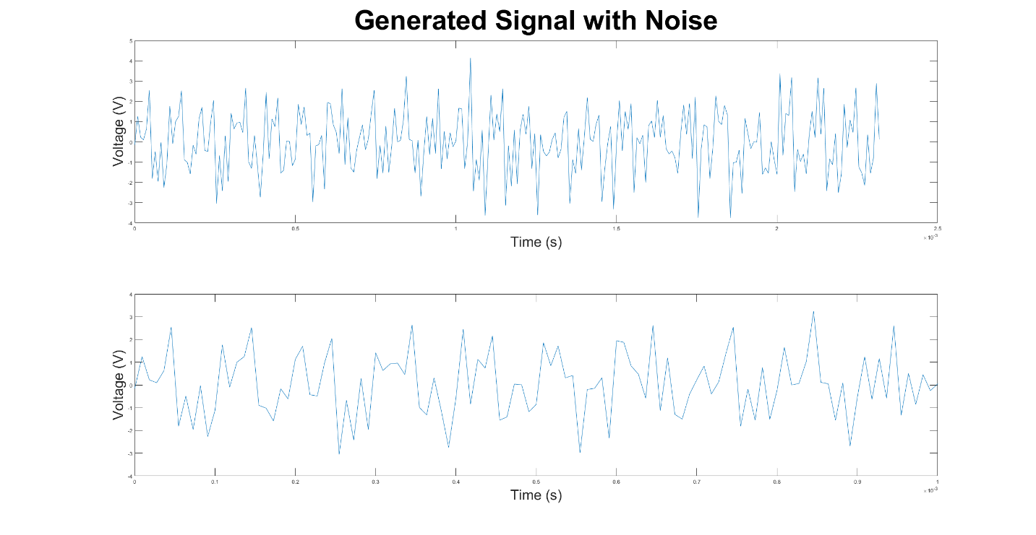

Figure 8: Three-frequency signal with noise, lower graph is zoomed in section of upper graph

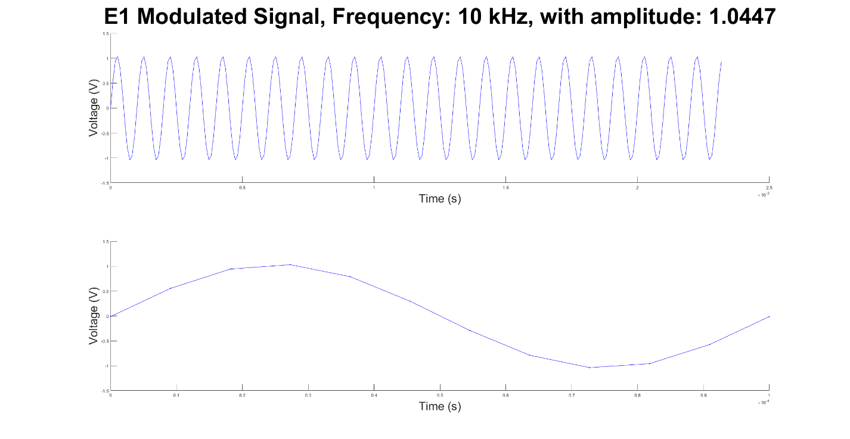

Figure 9: Quadrature demodulation for 10kHz extraction, lower graph is zoomed in version of upper graph

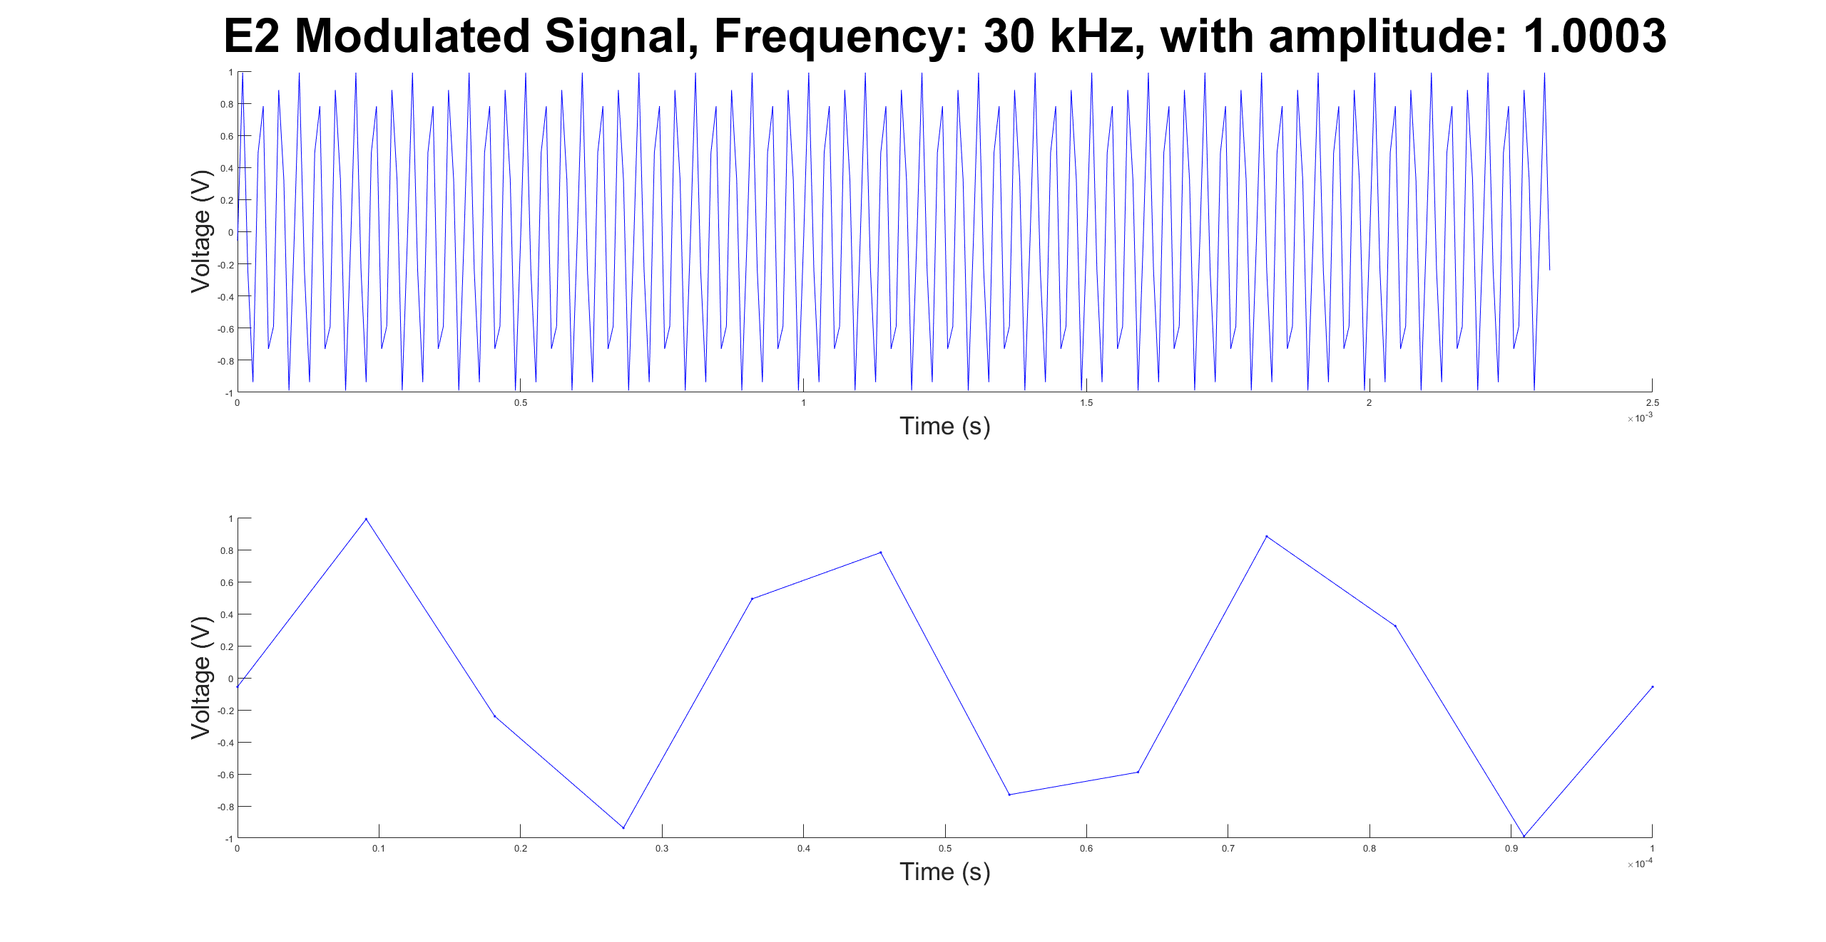

Figure 10: Quadrature demodulation for 30kHz extraction, lower graph is zoomed in version of upper graph

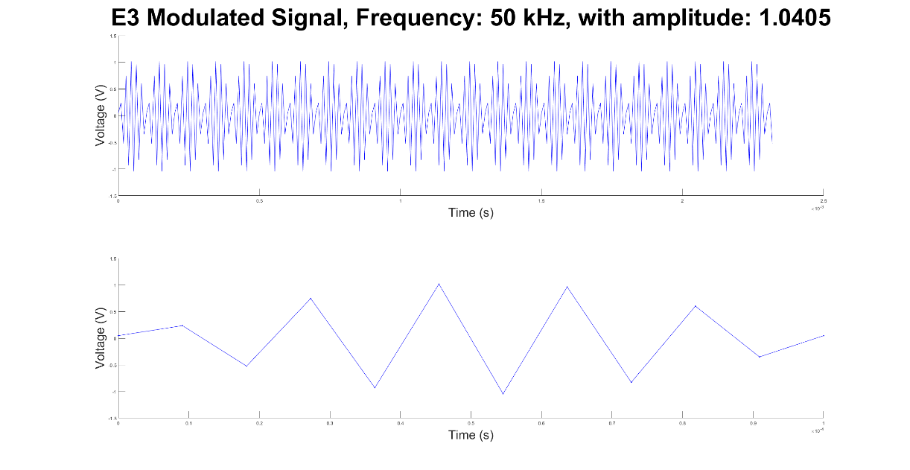

Figure 11: Quadrature demodulation for 50kHz extraction, lower graph is zoomed in version of upper graph

Figure 12, Summed Demodulated signal to recreate original signal with noise removed

## 4.4 Evaluation of Control System

### **4.4.1 Purpose of Evaluation**

The purpose of the central control system is to direct all circuits and signals with a desktop computer and MATLAB. The system used the NI PCI boards for analog and digital outputs to control the Howland current source, mux current direction, electrode current selection. The criteria that the control system needed to meet were simple; direct current flow to appropriate electrodes. The pattern followed was one where the two bipolar currents are to be spaced apart by four electrodes in a 16-electrode set up, at all times, in a clockwise pattern and was verified by oscilloscope voltage measurements.

### **4.4.2 Test Methods**

The first test that took place was to ensure the MUX control circuit could be controlled properly by the MATLAB script and NI board. Verification of the MUX control circuit was done by wiring the select bit pins to digital output pins of the NI board and ensuring that an output signal could be directed to the output from one of the 16 input channels desired.

After verification that the MUX control circuit functioned properly, the electrodes were wired to the outputs of the MUX control circuit. The Electrodes required switches to be digitally controlled by digital output pins on the NI board. The MATLAB script was modified to time the output electrode switches to connect to the outputs of the MUX circuit. The script was then stepped through to ensure that the MATLAB script was properly controlling the digital outputs to direct the current flow to the proper electrodes. This testing was done in phases of testing 4 electrodes, then 8, and finally 16. Testing was done over resistors as well as over a saltwater tank created for testing, which is shown in Figure 4.4.2.1, below.

Figure 4.4.2.1: Example of test set up for salt water testing tank

### **4.4.3 Results and Discussion**

Results of testing electrode measurements over resistors and the testing tank are shown below. Figures 4.4.3.1 and 4.4.3.2 show testing of voltage readings over the saltwater testing tank using 4 electrodes, using a skip 0 pattern. Figure one shows voltage readings without a ground connected electrode, which was built into the center bottom of the tank. Figure 4.4.3.2 shows the same setup but with the grounding electrode connected to circuit ground. To note is the fact that in Figure 4.4.3.1, the Measured Raw Data plot does not show the two injection currents, which are of the greatest amplitude, 180 degrees out of phase as they should be. However, Figure 2 shows the two greatest amplitude signals of the raw data as properly 180 degrees out of phase. In the Current Raw Data of both Figures 4.4.3.1 and 4.4.3.2, the amplitudes of current do not match in amplitude as they should. Figure 4.4.3.1 Raw Data Measurements does show voltage readings that are expected, however there is a slight issue in a difference of amplitude that can be seen in the two greatest amplitude sine waves.

Figures 4.4.3.3 and 4.4.3.4 are voltage measurements using an 8-electrode system over resistors instead of the saltwater testing tank. Measurements present the same characteristics noticed in the 4 electrodes system. The main difference would be that in Figure 4.4.3.3, the measurements with a 100 kilo-Ohm in parallel with the 1 kilo-Ohm resistors connecting the electrodes to ground has a significantly smaller voltage, as would be expected, for the electrodes not with an active injection current.

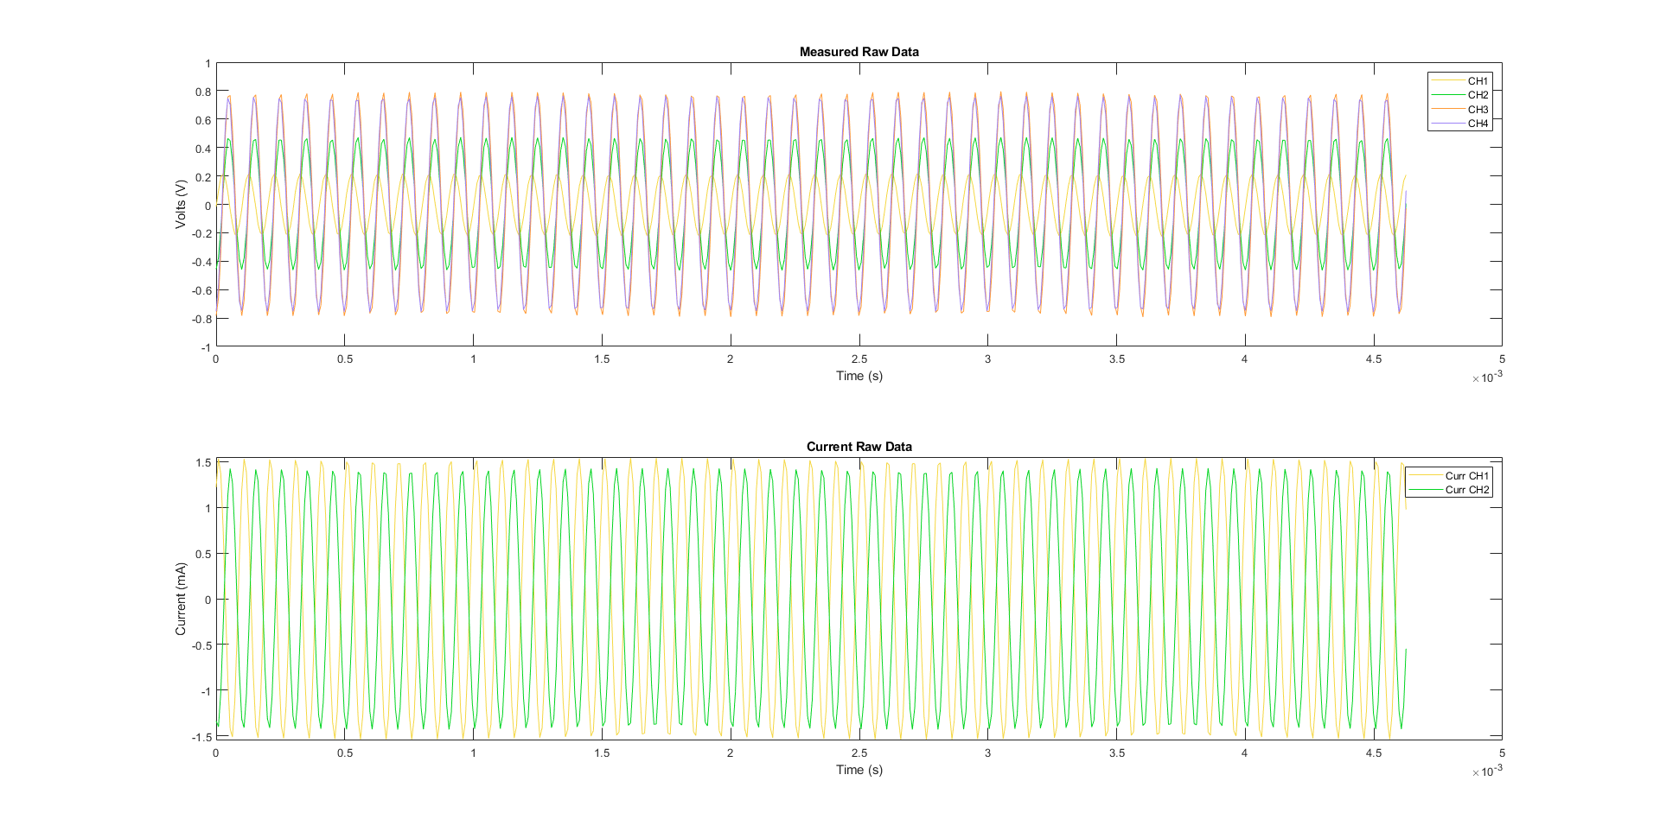

Figure 4.4.3.1: Test showing voltage readings from 4 electrodes without a ground on the tank with skip zero pattern

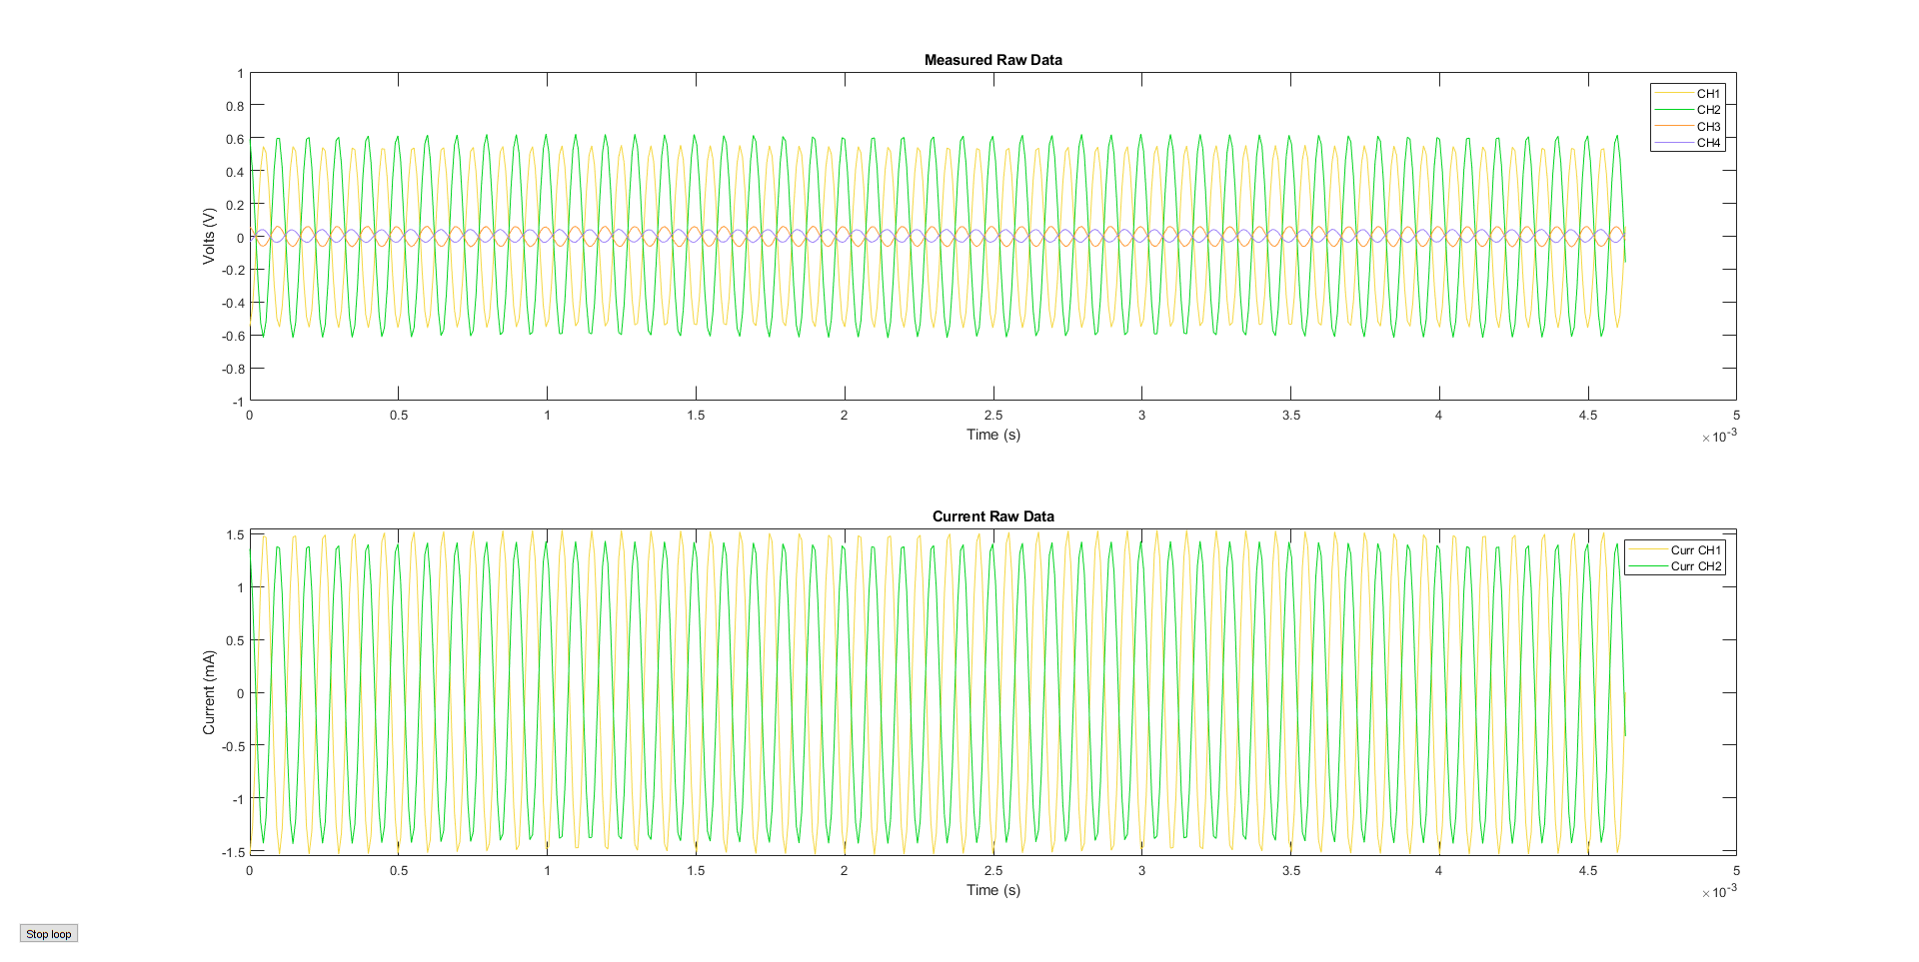

Figure 4.4.3.2: Test showing voltage readings from 4 electrodes with a ground on the tank with skip zero pattern

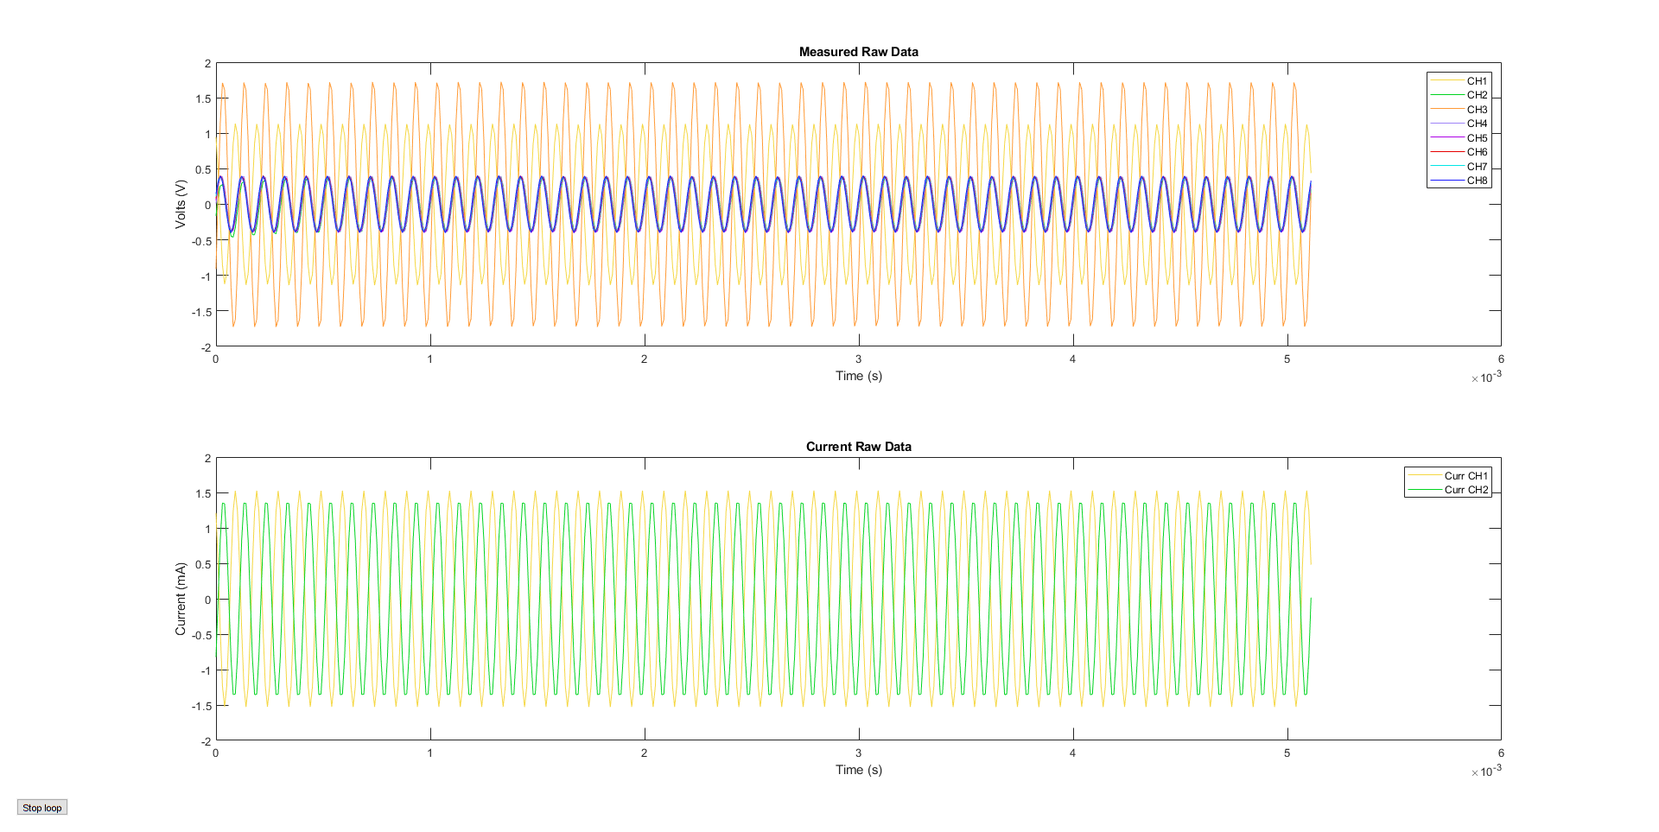

Figure 4.4.3.3: Shows a plot of the voltage readings while testing 8 electrode channels over resistors instead of the tank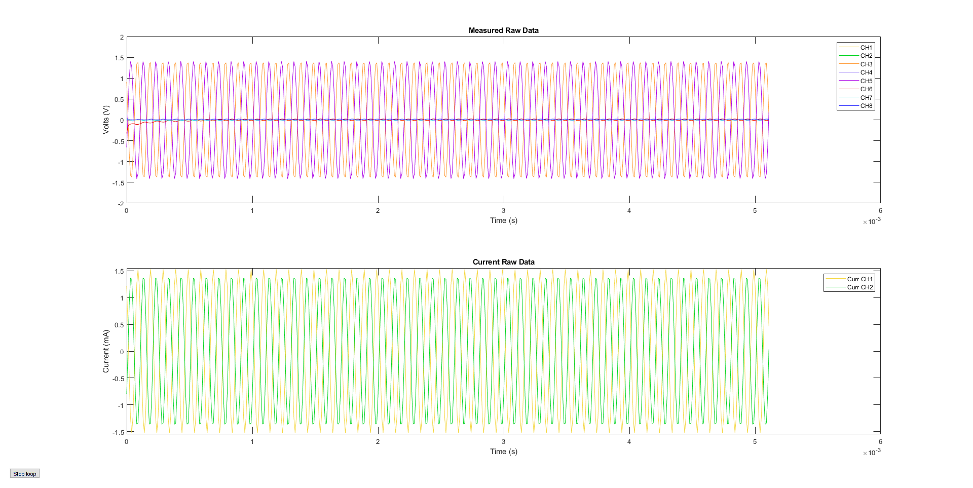

Figure 4.4.3.4: Shows a plot of the voltage readings taken while testing 8 electrode channels over resistors with a 100 kilo-Ohm resistor in series in parallel with 1kilo-Ohm resistors connecting the electrodes to ground to simulate the grounding electrode of the testing tank

Figures 4.4.3.5 and 4.4.3.6 show voltage readings for the test set up of an 8-electrode system connected to the saltwater testing tank. The same characteristics of the voltage readings from this set up parallel exactly what was observed with the 4-electrode set up. The voltage amplitude difference between the two injection electrodes is greater than that observed in the 4-electrode set up.

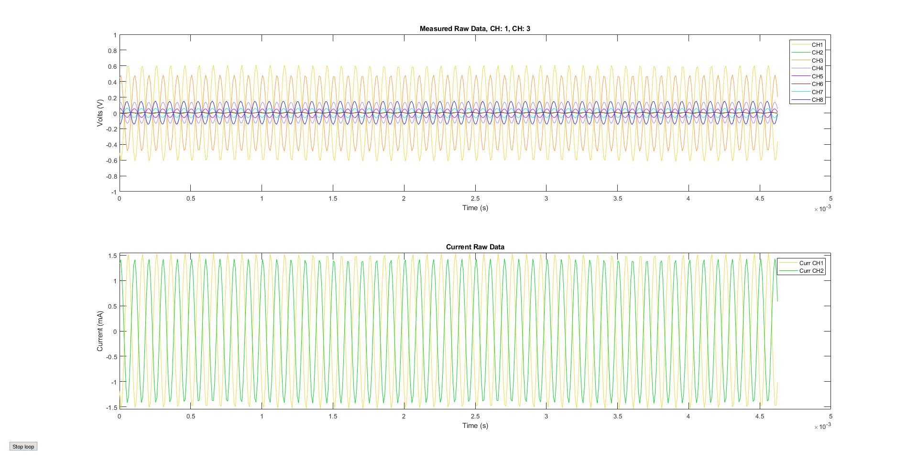

Figure 4.4.3.5: Shows a plot of the voltage readings taken while testing 8 electrode channels over the testing tank with a ground connected to the ground electrode

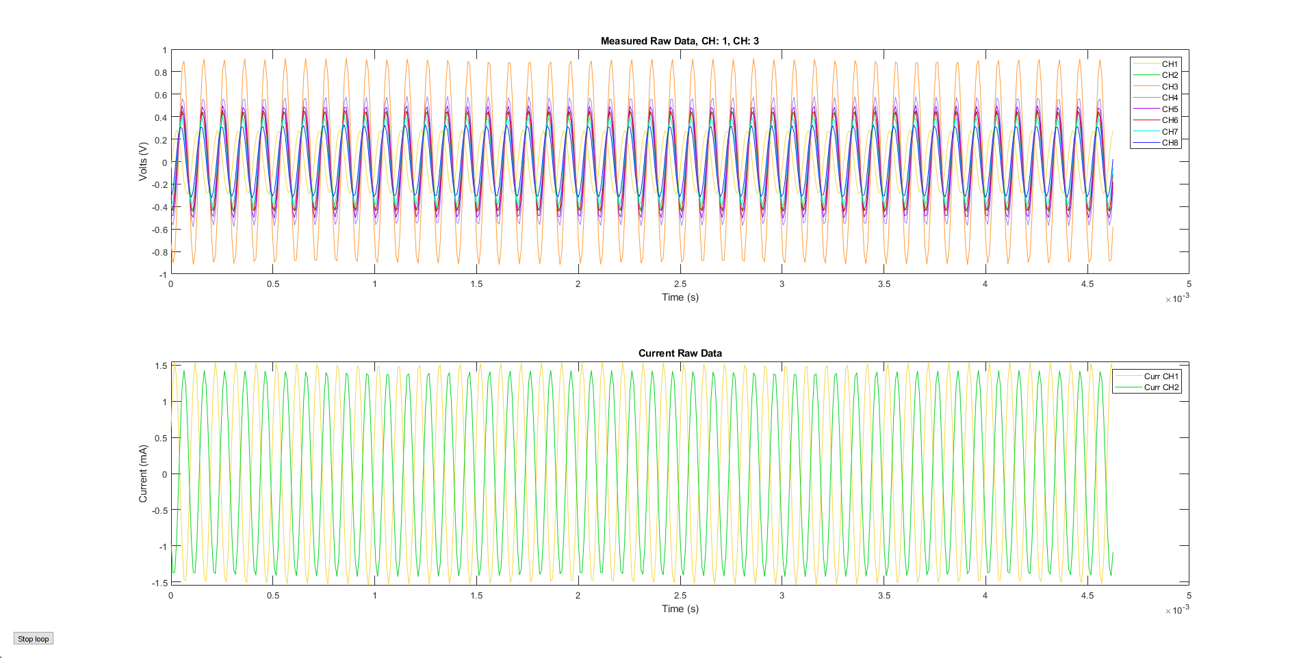

Figure 4.4.3.6: Shows a plot of the voltage readings taken while testing 8 electrode channels over the testing tank without a ground connected to the ground electrode

## 4.5 Evaluation of Data Processing

### **4.5.1 Purpose of Evaluation**

Data processing was done by reading analog voltage readings from ADC pins of the NI board. This was originally desired to be done with 32 electrodes but was reduced to 16 due to limitations of the NI board. The sample size 1024 voltage readings were possible with the NI board and MATLAB and simply needed to be coded in the control script. The sampling rate of 1 Ms/s was not possible due to the NI board reducing sample rate from the max 1 Ms/s with the addition of each ADC channel used, resulting in 110 kS/s with 16 channels for electrodes and 2 channels for current measurement. The voltage readings gathered in its 1024 sample by ADC pins were then processed by the quadrature demodulation technique explained in section 4.3. To further process the data processed by quadrature demodulation, the results were then processed by a script provided by Dr. Santos which cannot be explained further than that it processes the data to produce an image, due to proprietary reasons.

### **4.5.2 Test** **Methods**

* Array of data sent to QD
* Then sent to image processing script
* Should result in image
* Will have to complete later

### **4.5.3 Results and Discussion**

* To be done later

## 4.6 Evaluation of CNC Milled PCB Process

### **4.6.1 Purpose of Evaluation**

For the initial iteration of the EIT machine developed at the Colorado Mesa University campus, a crucial requirement was to prototype all circuits using CNC-milled PCBs. This was accomplished largely thanks to the dedicated efforts of Jake Seman, a student in the electrical and computer engineering program, whose detailed process can be found on GitHub [9]. Jake's process outlines the steps of converting design files from KICAD, a PCB design program, into GRBR files for milling on a CNC machine using Flatcam, and then milling on a CNC machine using the GRBR files with the Candle program.

The objective was to evaluate whether the performance of the CNC-milled PCBs met the specified requirements. The evaluation aimed to determine if the milled PCBs functioned correctly according to their intended circuit designs.

### **4.6.2 Test Methods**

To assess the quality of milled PCBs, a combination of visual inspection and continuity checks can be employed. It is imperative that all traces are properly isolated and connected from node to node. Initially, the traces can be visually examined to ensure their integrity. Subsequently, for a more objective evaluation, continuity checks are performed to verify that the traces are routed as intended.

### **4.6.3 Results and Discussion**

Initially, this process encountered numerous human errors; however, it has since been optimized. As the group gained experience and was able to produce a board in under an hour and achieve approximately a 2/3 success rate in continuity testing. While this process is not as robust as desired, it significantly expedites prototyping compared to outsourcing the boards.

## 4.7 Conclusion and Next Steps

The completion of all major components, encompassing the control system, signal injection, and data acquisition, signifies the fulfillment of our group's proof of concept objectives. However, it's important to acknowledge that not all specifications have been entirely met at this stage.

Particularly, the signal injection functionality employing the Howland current source requires scrutiny to ensure a consistent current output across the anticipated impedance range of the test subject. Moreover, the current design involves numerous interconnecting wires linking distinct circuits. To enhance efficiency and streamline the setup, there's an opportunity to consolidate the multiplexer and Howland into a single circuit, thereby reducing wiring complexity.

Furthermore, while the use of single-layer, in-house milled PCBs facilitated rapid prototyping, it limits the sophistication of the designs. To overcome this limitation and enable the implementation of more advanced features, it is advisable to outsource the final circuit designs to produce more refined and technologically advanced PCBs.

The subsequent phase of data acquisition involves transitioning away from the NI boards. Given the project's open-source nature, reliance on costly proprietary equipment should be minimized. Instead, the next iteration would entail designing or employing more affordable and accessible components for data collection purposes. This approach will be the primary focus of next year's project, as it promises enhancements in sampling rate and accuracy. Additionally, it will enable the incorporation of higher frequency injection signals, further augmenting the system's capabilities.

The next step for enhancing the control system involves transitioning from MATLAB to Python as an intermediate step. This transition is aimed at facilitating a more real-time design approach. Python will play a crucial role in improving the user interface and refining the timing of the system, enabling the implementation of multi-threading for simultaneous data acquisition and signal processing.

Moving away from using the NI boards is also desired. This is because the max sample rate of ADC channels of 1 MS/s is divided by the number of ADC channels being used, giving a max sample rate of 125 kS/s while still being able to achieve imaging. It is recommended that further development implements microcontrollers or FPGAs to process analog voltage measurements into an image.

The control system is working for an 8-electrode set up. However, there is the difference in voltage amplitude noticed for the electrodes injecting current, as can be seen in Figure 4.3.3.2 and 4.3.2.5. This can be corrected by increasing the input voltage signal to the smaller amplitude signal being sent to the Howland current source.

* + Need to get to 16-electrode set up
  + Need to get image processing done

# 5. Impact of Engineering Solutions

The type of impact that the production of the Electrical Impedance Tomography (EIT) machine is aimed to be an overwhelmingly positive one. With the goal of making a relatively cheap medical imaging device even cheaper, the team creating the EIT machine aims to help place this technology in more hospitals and in the hands of people with little to no funding needed. With this goal in mind, precautions need to be taken to ensure that potential negative effects on the environment, the economy, and society at the local and global levels are minimized. Therefore, potential hazards are to be discussed.

## 5.1 GLOBAL IMPACTS

There are positive global and local impacts that may stem from the project's main purpose of this machine, which is to create an open-source EIT machine. This will allow the medical imaging technique to be more widely accessible and could lead to the future of the industry. There are limited source versions of EITs out there because most are funded by schools and medical device companies who keep most fundamental discoveries from research to themselves. Creation of this open-source machine will allow the industry to have more information as time goes on. It will lead to more designs at a cheaper rate, help streamline the design process, allow other engineers to reference our design, and allow others to assess both the pros and cons of this design.

EIT is considered much safer than other common medical imaging. An EIT machine is non-ionizing and is used for dynamic imaging. While X-rays use electromagnetic radiation to create images of the body's internal structures. The radiation can lead to long-term health effects like skin burns, loss of hair, and increased incidence of cancer [10]. Magnetic Resonance Imaging (MRI) is much safer than X-ray imaging, however the cost is very high and MRI machines do not have much portability.

The EIT imaging process can help monitor lung function, brain activity, and even breast cancer. It has the potential to provide real-time imaging for various medical conditions, reducing the need for invasive procedures and radiation exposure. With this more widely available with the potential to increase society's health. This medical resource will be more affordable and with that, it'll be more widely used. Allowing people to understand what's happening inside their body. Published by the International Electrotechnical Commission (IEC), the IEC 6061 is a list of technical standards for the safety and performance of medical electrical equipment.

## 5.2 ECONOMIC IMPACTS

The creation of the proposed EIT machine design will have positive economic impacts at the local and global scales. This is because the cost for a hospital to buy most medical imaging devices is very high. This cost is passed on to medical facility patients who can see bills in the thousands of dollars for one round of imaging.

Magnetic Resonance Imaging (MRI) is one of the most effective and safest imaging techniques available. They are, however, not safe to use on anyone with implanted medical devices that consist of electrical or metal components and is also one of the most expensive for medical facilities to acquire. A low-end MRI machine can cost around $150,000, with typical costs for a device ranging from $1 to 3 million for a single MRI machine [11].

X-ray imaging is less expensive but is one of the more health adverse options for medical imaging. It is also one of the less versatile as its main use is on the imaging of bones. Portable x-ray devices may range from $5 to $60 thousand dollars. Portable devices are less versatile than their stationary counterparts commonly found in hospitals, which are necessary for general and emergency care use. Stationary x-ray machines can range from $35,000 to $200,000 [12].

Ultrasound devices are considered the safest classical medical imaging devices, and one of the cheapest. They do have limitations though, as they cannot penetrate bone, air filled cavities, and cannot penetrate deep into the body [13]. Low end devices may cost from $5,000 to $10,000. Mid-grade to high end ultrasound devices cost from $20,000 to $200,000.

As EIT is one of the youngest medical imaging technologies, it is also one of the least developed. From directly messaging the medical device company Dräger, the team received a quote of $60,000 dollars for their device. This is far above what the team believes an open-source EIT machine could cost, with high quality imaging. Using relatively inexpensive components, the team estimates that construction of an EIT machine could cost no more than a few thousand dollars at most.

If such cheap medical imaging devices for heart, lungs, brain, and breast cancer were available, it could drastically reduce the cost for hospitals to view these parts of the body. These savings would be past on to patients. Therefore, a relatively cheap, open source EIT machine would have an overwhelmingly positive economic impact.

## 5.3 ENVIRONMENTAL IMPACTS

EIT devices may contain materials such as heavy metals and toxic materials, as all electronic components do, especially when it comes to printed circuit boards (PCBs). This type of waste material is commonly called e-waste. E-waste can contain substances such as lead, mercury, and other metals, flame retardants, and certain phthalates [14]. This weighs into the economic and environmental impacts because most local ordinances require an individual or business to pay to have e-waste properly disposed of. In the case of the design presented in this paper, PCBs will be constructed, wires will connect PCBs and components, and some wire connected electrodes will have been used. Therefore, the only 2 precautions needed are to properly recycle e-waste upon disposal of the EIT machine, or its components, at places like local landfills.

While the disposal of e-waste can have negative effects on the environment, the manufacturing process involves the extraction of raw materials, energy consumption, and transportation, all of which have environmental consequences [[15]. Fossil fuels are used to mine raw materials and fossil fuels are also used to transport raw materials and manufactured components. Although extraction and transportation of raw materials is argued to negatively impact the environment, it is impossible to get the components required for an EIT machine without these effects. It is currently widely considered more important to have access to electronic components than it is to avoid any possible negatives.

## 5.4 SOCIETAL IMPACTS

There are possible humanitarian concerns when it comes to conditions for workers in fabrication facilities related to the production of electronic components. In China for example, Apple device manufacturing facilities have worker conditions documented which many would call cruel and border basically slavery. Cheap labor and lax environmental regulations have led to concerns about worker rights and pollution [16]. This is not the case for all electronic component factories. And there are no known or reasonably suggestable reasons for concerns about humanitarian issues from any electronic component manufacturer that is involved in the production of any electronic component or PCB in the current design plan for the EIT machine.

When considering potential environmental, economic, global, and local costs to the potential benefit of the EIT machine design and its implementation, the benefits far outweigh the costs. Environmental negative impacts are small. Positive economic, global, and local impacts are potentially extremely positive. Medical bills for imaging certain parts of the human body can be severely reduced. EIT imaging could even be brought to remote parts of the world without power grids, given a sufficient and stable power source. EIT has the potential to be designed by hobbyists and those with the need for it, safely, in their own homes. Overall, EIT will have a positive impact on the world and has the potential to improve the health of people around the world.

# 5. References

[1] “Electrical impedance tomography,” *Wikipedia*. Sep. 17, 2023. Accessed: Oct. 19, 2023. [Online]. Available: https://en.wikipedia.org/w/index.php?title=Electrical_impedance_tomography&oldid=1175791739

[2] S. Mansouri, Y. Alharbi, F. Haddad, S. Chabcoub, A. Alshrouf, and A. A. Abd-Elghany, “Electrical Impedance Tomography – Recent Applications and Developments,” *J Electr Bioimpedance*, vol. 12, no. 1, pp. 50–62, Nov. 2021, doi: 10.2478/joeb-2021-0007.

[3] “Talles Santos | Colorado Mesa University.” Accessed: Oct. 27, 2023. [Online]. Available: https://www.coloradomesa.edu/directory/computer-science-engineering/talles-santos.html

[4] “Electrical Impedance Tomography (EIT) Device - LuMonTM,” Sentec. Accessed: Nov. 14, 2023. [Online]. Available: https://www.sentec.com/electrical-impedance-tomography/

[5] “Electrical Impedance Tomography | Draeger.” Accessed: Nov. 14, 2023. [Online]. Available: https://www.draeger.com/en_uk/Hospital/Electrical-Impedance-Tomography

[6] “Sciospec’s EIT Electrical Impedance Tomography - Sciospec.” Accessed: Nov. 14, 2023. [Online]. Available: https://www.sciospec.com/eit/

[7] “IEC 60601,” *Wikipedia*. Apr. 08, 2023. Accessed: Nov. 14, 2023. [Online]. Available: https://en.wikipedia.org/w/index.php?title=IEC_60601&oldid=1148739103

[8] “ANSI/AAMI ES60601-1:2005/Amendments - Medical electrical equipment — Part 1: General requirements for basic safety and essential performance, Amendments.” Accessed: Nov. 14, 2023. [Online]. Available: https://webstore.ansi.org/standards/aami/ansiaamies606012005amendments

[9] J. Seman, “Jbsco/PCB_MFG.” Mar. 21, 2024. Accessed: Apr. 09, 2024. [Online]. Available: https://github.com/Jbsco/PCB_MFG

[10] “Risks of Radiation,” UCSF Radiology. Accessed: Oct. 27, 2023. [Online]. Available: https://radiology.ucsf.edu/patient-care/patient-safety/radiation-safety/risks-of-radiation

[11] “Why Are MRIs So Expensive at Hospitals?,” Heartland Imaging. Accessed: Oct. 27, 2023. [Online]. Available: https://heartlandimagingcenters.com/2021/03/19/why-are-mris-so-expensive-at-hospitals/

[12] C. Hutchison, “What Is the Average Cost of an X-Ray Machine? [Updated 2023].” Accessed: Oct. 27, 2023. [Online]. Available: https://www.mavenimaging.com/blog/average-x-ray-machine-cost

[13] “Ultrasound - Mayo Clinic.” Accessed: Oct. 27, 2023. [Online]. Available: https://www.mayoclinic.org/tests-procedures/ultrasound/about/pac-20395177

[14] K. K. Kefeni, J. O. Okonkwo, O. I. Olukunle, and B. M. Botha, “Brominated flame retardants: sources, distribution, exposure pathways, and toxicity,” *Environ. Rev.*, vol. 19, no. NA, Art. no. NA, Dec. 2011, doi: 10.1139/a11-010.

[15] “Natural-Resource Use and Environmental Impacts | One Planet network.” Accessed: Oct. 27, 2023. [Online]. Available: https://www.oneplanetnetwork.org/SDG-12/natural-resource-use-environmental-impacts

[16] “How the iPhone Helps Perpetuate Modern-Day Slavery,” HuffPost. Accessed: Oct. 27, 2023. [Online]. Available: https://www.huffpost.com/entry/how-the-iphone_b_5800262

# 6. Appendices

**A:**

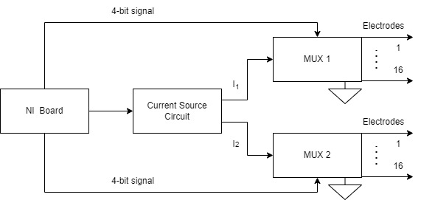

Figure 13: Shows a diagram of the control circuit used to direct current from the current circuit to the electrodes.